**Experiment 6**

**Study of Root Locus Plot in Matlab**

**Aim:** To study following:

* Stabilty analysis of linear process by gain variation method and by root locus method of the given TF.

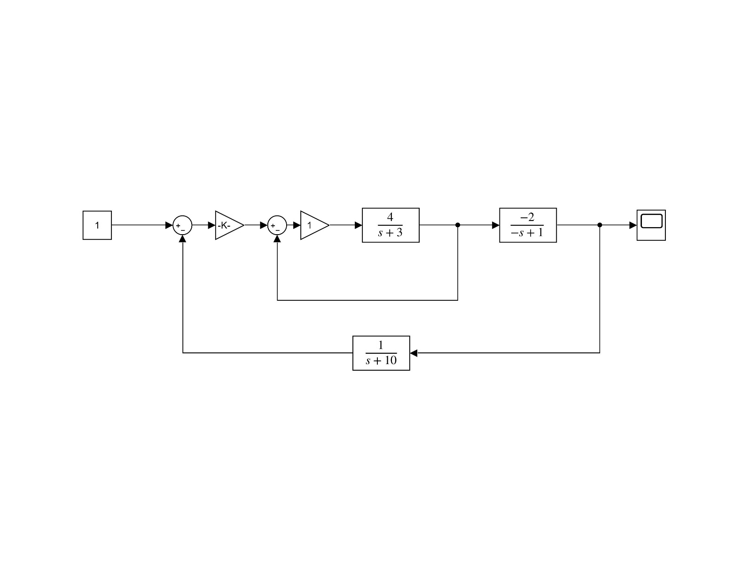

Fig 1: Given Transfer Function

* Stability analysis of linear process by gain variation on kit.

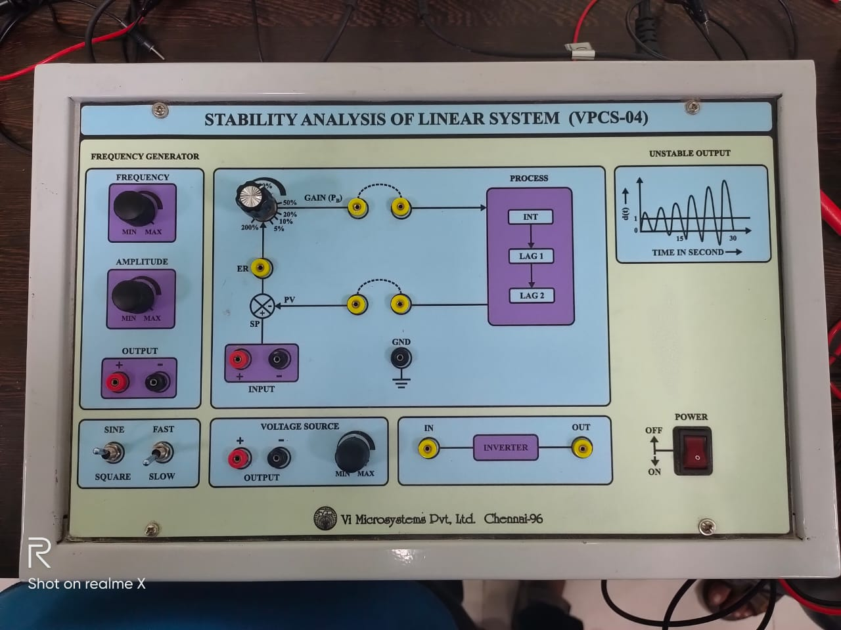

Fig 2: Controller box

**Software:** MATLAB 2018a

**Theory:**

**Root Locus:** The root locus of a feedback system is the graphical representation in the complex s-plane of the possible locations of its closed-loop poles for varying values of a certain system parameter. The root locus is a graphical representation in s-domain and it is symmetrical about the real axis. Because the open loop poles and zeros exist in the s-domain having the values either as real or as complex conjugate pairs. On a root-locus graph, all the poles move towards a zero. Only one pole may move towards one zero, and this means that there must be the same number of poles as zeros.

**Controller Box:** A proportional–integral–derivative controller (PID controller. or three-term controller) is a control loop mechanism employing feedback that is widely used in industrial control systems and a variety of other applications requiring continuously modulated control. A PID controller continuously calculates an *error value* e(t) as the difference

between the desired setpoint (SP) and a measured process variable (PV) and applies a correction based on proportional , integral , and derivative terms (denoted *P* , *I* , and *D* respectively)

**Matlab Code:**

clc; clear all; close all;

s = tf('s');

g1 = 0.5;

g2 = 4/(s+3);

g3 = -2/(-s+1);

h = 1/(s+10);

Y = series(feedback(series(g1,g2),1),g3);

rlocus(Y*h);

**Results:**



Fig 3: Root Locus

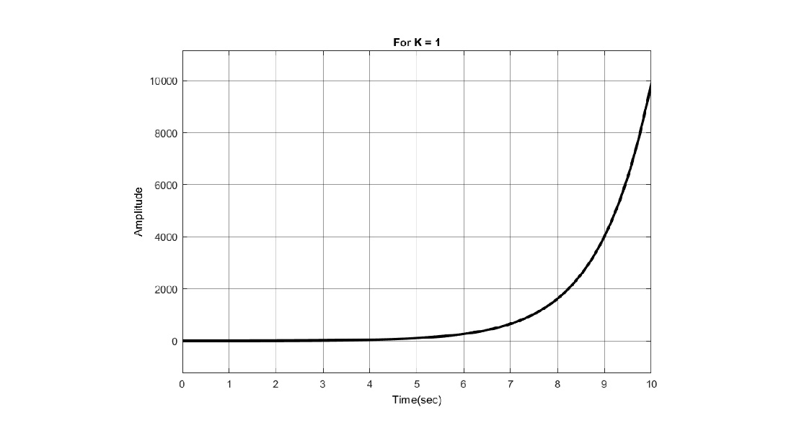

Fig 4: For k not in root locus Fig 5: For K in root locus

**Conclusion:**

**For Root Locus**

* After locating k on the Root Locus, the system stabilizes, and stable response is obtained
* On a root-locus graph, all the poles move towards a zero. Only one pole may move towards one zero, and this means that there must be the same number of poles as zeros.
* Range of k for stability = (1-105)

**For Controller Box**

* On increasing k, the systems tends to get unstable.
* Response of such a system shows increasing amplitude.

**Assignment 6a**

**Aim:** To Study Root Locus of a system with PID controller in MATLAB. 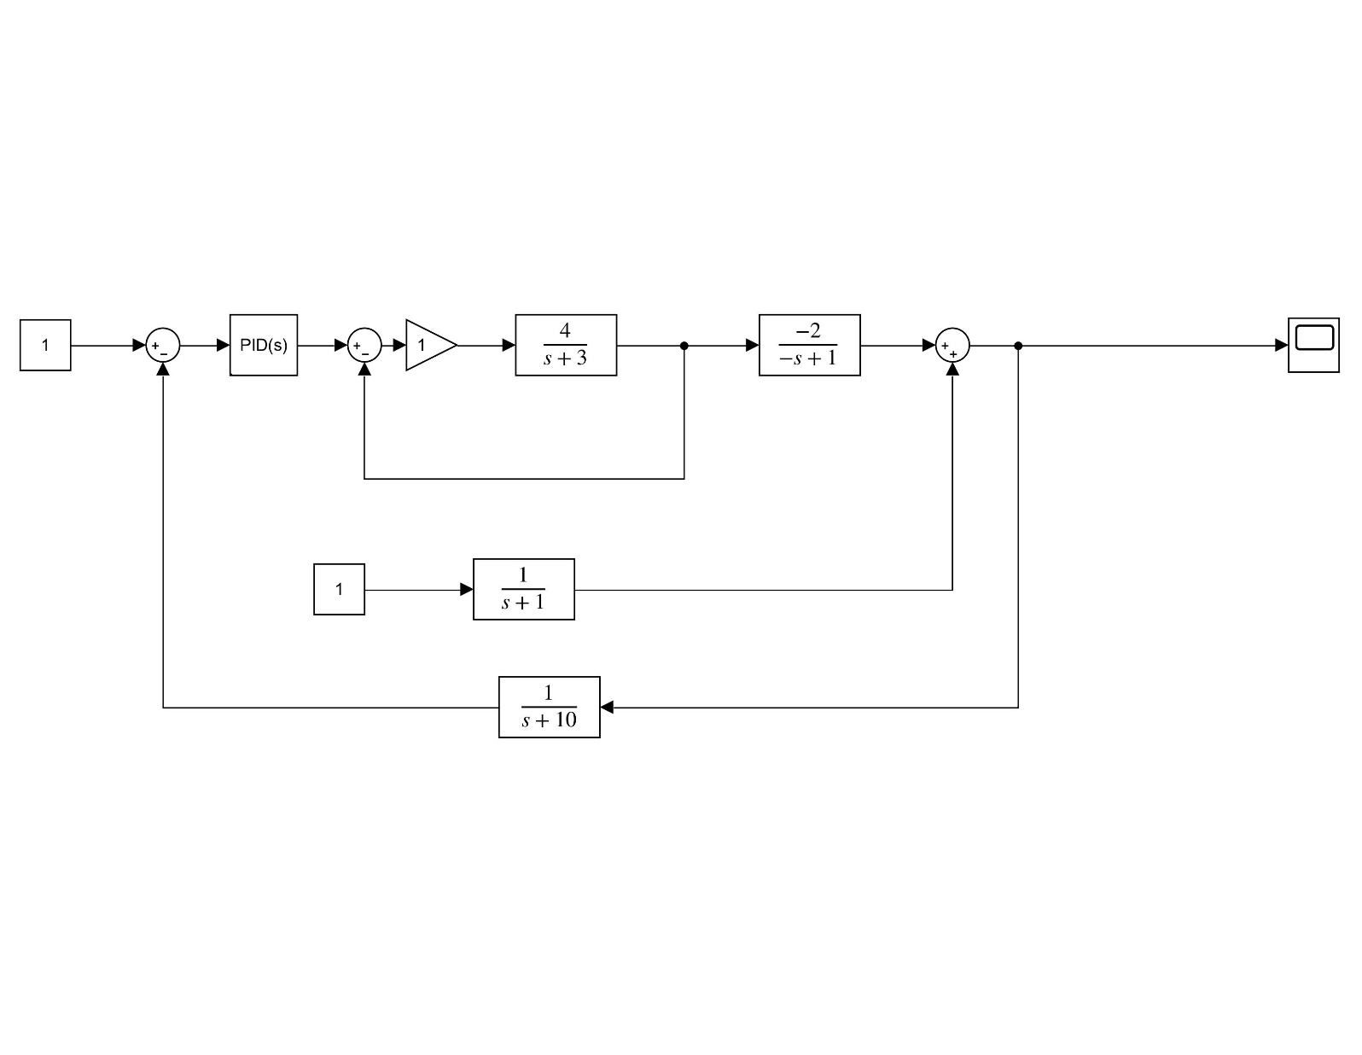

**Software:** Matlab 2018a

**Theory:** In control system theory, the Routh–Hurwitz stability criterion is a mathematical test that is a necessary and sufficient condition for the stability of a linear time-invariant (LTI) control system. Stability can be characterized by considering a sign of real parts of the roots of the characteristic polynomial of a linear system. If all entries in the routh array are positive, implies a stable system, negative entry implies instability, 0 implies threshold condition.

**Matlab Code:**

close all;

clear; clc;

Gp = series(tf([1 1 1],[1 0]), series(feedback(tf(2,[1 3]), 1), tf(-2,[-1 1])));

H = tf(1, [1 10]);

rlocus(Gp*H);

**Results:**

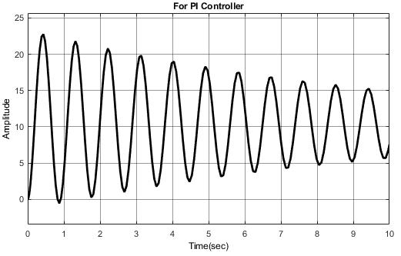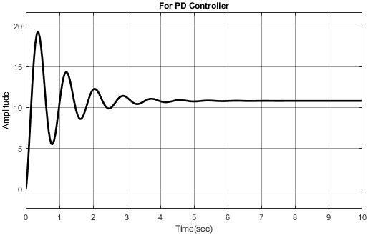

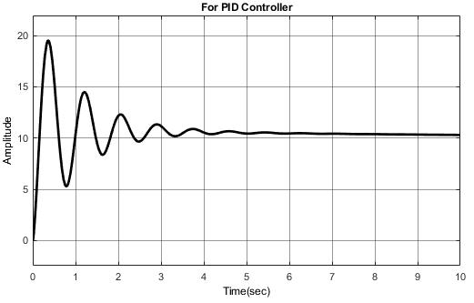

**Conclusion:**

* After locating k on the Root Locus, the system stabilizes, and stable response is obtained**.**
* Step response was studies for different values of disturbances.

**Date – 23-09-2019**

**Control System Lab (EEP310)**

**Date – 23-09-2019**

**Control System Lab (EEP310)**